1. **Define a friend function addTime() with objects as arguments and return the sum of two objects. Show the values of each object and their sum as output.**

**PROGRAM**

#include<iostream>

using namespace std;

class Time {

private:

int hour, minute;

public:

Time() {

hour = 0;

minute = 0;

}

Time(int hour, int minute) {

this->hour = hour;

this->minute = minute;

}

friend Time addTime(Time t1, Time t2);

void display() {

cout<<"Hour: "<<hour<<endl<<"Minute: "<<minute<<endl;

}

};

Time addTime(Time t1, Time t2) {

Time temp;

temp.hour = t1.hour + t2.hour;

temp.minute = t1.minute + t2.minute;

if (temp.minute >= 60) {

temp.hour += temp.minute / 60;

temp.minute %= 60;

}

return temp;

}

int main() {

Time t1(10, 50), t2(1, 11), t3;

t3 = addTime(t1, t2);

cout<<"Time 1: "<<endl;

t1.display();

cout<<"Time 2: "<<endl;

t2.display();

cout<<"Time 3: "<<endl;

t3.display();

return 0;

}

**OUTPUT**

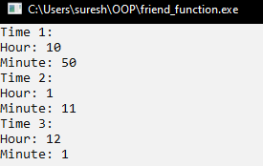

1. **Write different programs to implement passing by reference and passing by value in C++.**

**PROGRAM**

#include <iostream>

using namespace std;

void passByValue(int a) {

a = a * 2;

cout << "Inside passByValue function: " << a << endl;

}

void passByReference(int &a) {

a = a * 2;

cout << "Inside passByReference function: " << a << endl;

}

int main() {

int x = 5;

cout << "Before passByValue function: " << x << endl;

passByValue(x);

cout << "After passByValue function: " << x << endl;

cout << "Before passByReference function: " << x << endl;

passByReference(x);

cout << "After passByReference function: " << x << endl;

return 0;

}

**OUTPUT**

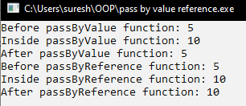

1. **Write different programs to implement different storage classes (auto, register, extern and static) in C++ with its output.**

**PROGRAM**

­ #include <iostream>

using namespace std;

int externVar = 100;

void displayExtern() {

cout << "Inside displayExtern function: externVar = " << externVar << endl;

}

void demonstrateAuto() {

auto autoVar = 10;

cout << "Inside demonstrateAuto function: autoVar = " << autoVar << endl;

}

void demonstrateRegister() {

register int registerVar = 20;

cout << "Inside demonstrateRegister function: registerVar = " << registerVar << endl;

}

void demonstrateStatic() {

static int staticVar = 30;

cout << "Inside demonstrateStatic function: staticVar = " << staticVar << endl;

staticVar++;

}

int main() {

cout << "Inside main function: externVar = " << externVar << endl;

demonstrateAuto();

demonstrateRegister();

demonstrateStatic();

demonstrateStatic();

externVar = 200;

displayExtern();

return 0;

}

**OUTPUT**

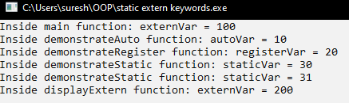

1. **Write a C++ program to illustrate dynamic allocation and de-allocation of memory using new and delete.**

**PROGRAM**

#include <iostream>

using namespace std;

int main() {

int* ptr = new int;

*ptr = 42;

cout << "Value of the single integer: " << *ptr << endl;

delete ptr;

int size = 5;

int* arr = new int[size];

for (int i = 0; i < size; ++i) {

arr[i] = i * 10;

}

cout << "Values in the array: ";

for (int i = 0; i < size; ++i) {

cout << arr[i] << " ";

}

cout << endl;

delete[] arr;

return 0;

} **OUTPUT**

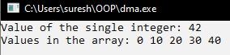

1. **Write a program using dynamic memory allocation to get input an array of numbers and find the sum of N numbers stored in the array using a function to compute the sum.**

**PROGRAM**

#include <iostream>

using namespace std;

int main() {

int* ptr = new int;

*ptr = 42;

cout << "Value of the single integer: " << *ptr << endl;

delete ptr;

int size = 5;

int* arr = new int[size];

for (int i = 0; i < size; ++i) {

arr[i] = i * 10;

}

cout << "Values in the array: ";

for (int i = 0; i < size; ++i) {

cout << arr[i] << " ";

}

cout << endl;

delete[] arr;

return 0;

}

**OUTPUT**

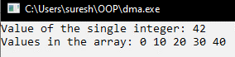

1. **Write a program to implement user defined constructor and copy constructor.**

**PROGRAM**

#include <iostream>

using namespace std;

class MyClass {

private:

int value;

public:

MyClass(int v) {

value = v;

cout << "User-defined constructor called with value: " << value << endl;

}

MyClass(const MyClass &other) {

value = other.value;

cout << "Copy constructor called, copied value: " << value << endl;

}

void display() {

cout << "Value: " << value << endl;

}

};

int main() {

MyClass obj1(10);

obj1.display();

MyClass obj2 = obj1;

obj2.display();

MyClass obj3(obj1);

obj3.display();

return 0;

}

**OUTPUT**

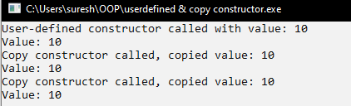

1. **Write a program to illustrate constructor overloading in C++.**

**PROGRAM**#include <iostream>

#include <string>

using namespace std;

class MyClass {

private:

int a;

double b;

string c;

public:

MyClass() {

a = 0;

b = 0.0;

c = "default";

cout << "Default constructor called" << endl;

}

MyClass(int x) {

a = x;

b = 0.0;

c = "default";

cout << "Constructor with one parameter called, a = " << a << endl;

}

MyClass(int x, double y) {

a = x;

b = y;

c = "default";

cout << "Constructor with two parameters called, a = " << a << ", b = " << b << endl;

}

void display() const {

cout << "a = " << a << ", b = " << b << ", c = " << c << endl;

}

};

int main() {

MyClass obj1;

obj1.display();

MyClass obj2(10);

obj2.display();

MyClass obj3(20, 30.5);

obj3.display();

return 0;

}

**OUTPUT**

